SUTAB Colonoscopy Prep Instructions
ARRANGEMENTS
- You will be given sedating medication for your procedure. After your procedure, you may NOT drive yourself home. You must be accompanied by an adult friend or family member to drive you home. You may not take a taxi, Uber, Lyft or car service. Failure to arrange a driver will result in cancellation of your procedure.
- DO NOT drive, work, make any personal or business decisions, or operate any heavy machinery for 24 hours after your procedure because the sedative can make you sleepy and forgetful.
- AVOID seeds and nuts for 1 week prior to your colonoscopy.
SUPPLIES
- Pick up your supplies for your colonoscopy 1 week prior of your appointment:
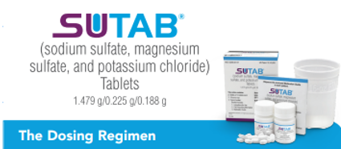
  - Pharmacy:1 SuTab bowel prep kit
**If you have difficulty taking pills, please call to arrange for an alternative prep: 303-761-8336**

  - Grocery Store:
  - 4- chewable tabs of Simethicone or Gas-X tablets (any flavor & any brand)
  - 2- Dulcolax or Bisacodyl tablet 5mg (any brand)
  - Clear Liquids (see list below).
Clear Liquid Diet: | Things to AVOID
- Clear Broth  - Clear Juice (apple, lemonade)  - Sport drinks (Gatorade, Powerade)  - Flavored Drinks (Kool-Aid, MiO)  - Hot Drinks (Tea, Coffee)  - Jello  - Hard Candy | - NO Red and Purple liquids  - NO Solid Foods  - NO Alcohol  - NO Pulp in Juice  - NO Nectar Drinks  - NO Dairy and Nondairy Creamer
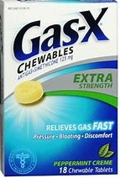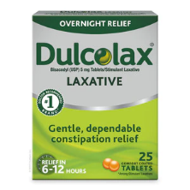
MEDICATIONS AND DEVICES
- Diabetes medications: please contact your prescribing provider’s office for instructions on taking.
- Blood thinning medications: (Eliquis, Coumadin, Xarelto, Pradaxa, etc.) ensure you have gotten pre-procedure instructions 1 week before your procedure. If not, please call the RN line: 303-761-8336.
- Prescription weight loss medications: (Phentermine) stop this at least 7 days before your procedure.
- DO NOT STOP heart, blood pressure or regular medications; unless told to do so.
- DO NOT STOP taking Naltrexone or Contrave.
- CPAP or Inhalers: FOR HOSPITAL PROCEDURES ONLY, please bring this with you.
PROCEDURE PREP INSTRUCTIONS
**PLEASE DISCARD INSTRUCTIONS INSIDE SUTAB BOX & FOLLOW THE INSTRUCTIONS ON THE BACK OF THIS PAGE**
PREPARING FOR YOUR COLONOSCOPY
ONE DAY BEFORE YOUR PROCEDURE: __________

- Start a CLEAR LIQUID DIET in the morning

***If your procedure is after 12:00PM tomorrow you may have a light breakfast (eggs, white toast) before 9:00AM today and then start a clear liquid diet. ***
DOSE 1  Start at 6:00 PM the Day Prior to Colonoscopy | DOSE 2  6 Hours Prior to Colonoscopy
- At 6:00PM prepare two Dulcolax 5mg tablets, 16oz. of water, and 12 SuTab tablets  - Take two Dulcolax 5 mg Tablets.  - Swallow each SuTab tablets, one by one, with a sip of water, allowing 2-3 minutes between each tablet and then finish drinking the remaining water in the container. Take the tablets over the course of 1 hour.  - Chew 2 Simethicone/Gas-X tablets.  - Between 7:30 and 8:00PM, drink the 2nd- 16 oz. container of water over 30 minutes.  - Between 8:30 and 9:00PM, drink the 3rd- 16 oz of water and drink over 30 minutes.  - After drinking all your water, you may drink any of the other clear liquids you have chosen throughout the evening. | - 6 hours before your procedure:_______  prepare 16oz. of water and 12 SuTab tablets  - Swallow each of the 12 tablets, one by one, with a sip of water, allowing up to 3 minutes between each tablet and then drink all the water in the container. Do not rush taking the tablets.  - Chew 2 Simethicone/Gas-X tablets.  - 5 hours before your procedure:_________  Drink your two 16 oz. container of water over 1 hour.
DAY OF PROCEDURE 4 hours before your procedure:
STOP drinking all liquids, including water. This is for your safety. Anything after 4 hours can delay or cancel your procedure.
No gum, hard candy, chewing tobacco, cigarettes, marijuana, cigars, pipes, e-cigarettes, or illicit drugs.
***If you have any heart, blood pressure, anti-seizure medications you may take them
with small sips of water when you usually take these medications.***
IMPORTANT:
Following the second dose, your bowel movements should be clear, yellow, or tea colored. If bowel movements aren’t clear, yellow, or tea-colored, or contain any solids, please call the on-call physician: 303-788-8888 to be given further instructions or to discuss if you will need to be rescheduled.
Bring your ID, Insurance Card, & a Form of Payment for Check-in at:

